**RDBMS Lab Exercises**

**SQL Statements**

1. Given three relations- sailors, boats and reserves. Sid, Bid and (Sid, Bid) are the primary keys of sailors, boats and reserves respectively. Sid and Bid are also the foreign keys of reserves which references Sid and Bid of sailors and boats relation respectively. No two sailors have same rating.

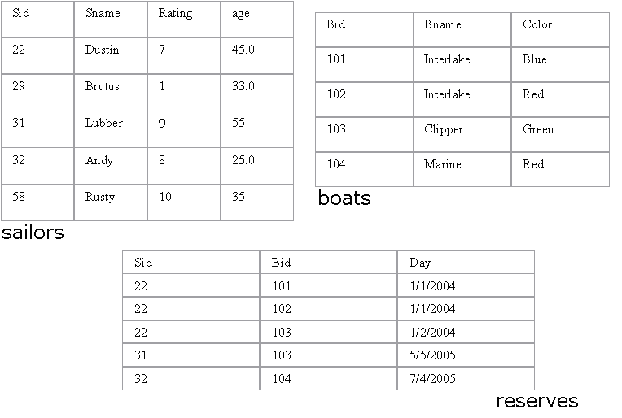

**Write SQL queries for the following:**

1. Find the names of sailors who have reserved a red boat.

2. Find the names of the Sailors who have reserved at least one boat

3. Compute increments for the ratings of persons who have sailed two different boats on the same day.

4. Find the ages of sailors whose name begins and ends with B and has at least 3 characters.

5. Find the names of sailors who have reserved a red and a green boat.

6. Find the sids of all sailors who have reserved red boats but not green boats.

7. Find the sailors with the highest rating

8. Find the name of the oldest sailor.

9. Count the number of different sailor names.

10. Find the no. of sailors who is eligible to vote for each rating level.

11. Find the no. of sailors who is eligible to vote for each rating level with at least

two such sailors.

12. Find the sid of the sailors who have sailed exactly one boat.

13. Find sailors who have not reserved any boats.

14. Find the Sailors who have reserved all the boats.

15. Find all the sailors older than Dustin.

16. Find all sailors whose ratings is greater than any others rating without using aggregates like MAX.

17. Find the sailors with 3rd highest ratings.

18. Find sids of the sailors who have reserved all the boats reserved by the sailor with sid =’31’.

19. List out all the sailors. For the sailors who have reserved some boats list out the boat’s bids also.

20. Assume that we have a table called customer.

|  |  |  |
| --- | --- | --- |
| CustID | Name | ReferredBy |
| 1 | Neeta Sayam |  |
| 2 | Dolly Dilly | 1 |
| 3 | Meena Kimi | 2 |

21. Find the names of all customers who are referred by others.

22. Find the names of all customers who have referred others.

23. Find the last three customer records inserted. (Refer the above Customer table)

1. Given a table ‘customer’.

|  |  |  |
| --- | --- | --- |
| CustID | Name | Age |
| 1 | Neeta Sayam | 32 |
| 2 | Dolly Dilly | 23 |
| 3 | Meena Kimi | 43 |

How will you get rows between the range x and y where x and y will be entered by the user?

1. Given three tables- sailors, boats and reserves. Sid, Bid and (Sid, Bid) are the primary keys of sailors, boats and reserves respectively. Sid and Bid are also the foreign keys of reserves which references Sid and Bid of sailors and boats relation respectively. No two sailors have same rating. The sname and bname of the sailors and boats table are cannot be null.



Queries:

1. Alter the Sailor table such that age is between 18 and 40.
2. Alter the Boats table such that color is Red, Blue or Green.
3. Assuming that all the tables are created as in 1, 2 and 3 alter the table (s) such that if a record from sailors table gets deleted, then the records corresponding to the same sailor also get deleted from reserves.
4. Drop primary key constraint from the reserves table.